**Individual Reflection: Front-end Developer  
Aimal Khan – 1820222024 – 麦默德  
------------------------------------------------------------------------------------------**

As the frontend developer for the chat application project, I was responsible for designing and implementing the user interface, ensuring a seamless and visually appealing experience. My work revolved around creating responsive layouts, integrating real-time functionality with the backend, and ensuring the app was intuitive for users. Below, I reflect on how I carried out my tasks, the challenges I faced, and the collaboration within the team.  
  
Here’s a visual representation: (I added a **Night** and **Day** view for our website)  
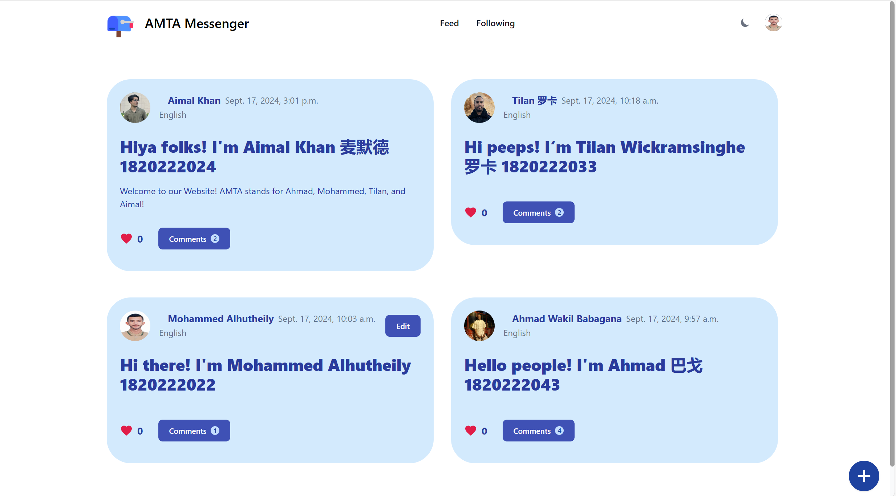

**UI/UX Design:**   
I used Tailwind CSS to create a modern, responsive design for the chat interface. This involved building user-friendly navigation, chat windows, user profile sections, and an overall aesthetic that aligned with the app’s purpose.

**Real-time User Interaction:**   
Using WebSocket and HTML/CSS, I worked closely with the backend developer to display real-time messages, online user status, and notifications, providing an interactive and dynamic experience. I made sure the frontend communicated effectively with the backend API by sending and receiving data through WebSocket’s and handling responses (JSON format) to update the UI dynamically.

**Cross-browser Compatibility:**I ensured that the chat application functioned consistently across multiple devices and browsers.  
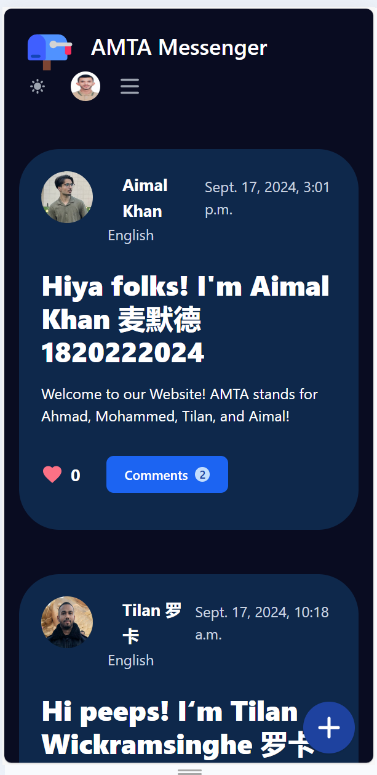 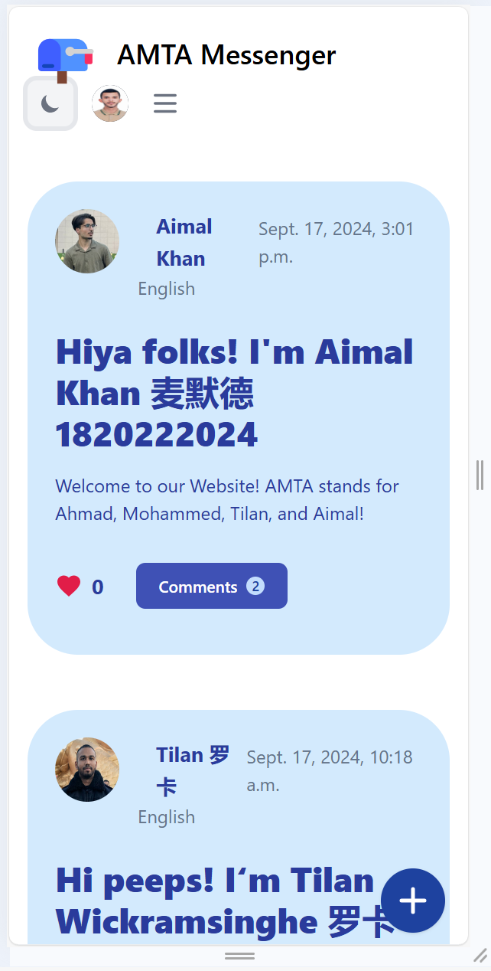

**Problems Encountered & How they were Resolved:**

Real-time Updates: One of the core challenges in front-end development for a chat app was displaying messages in real-time as they were sent and received. Any lag or delay would affect the user experience, so I had to ensure smooth communication with the backend. I worked closely with the backend developer to ensure the WebSocket integration was handled properly. I also used JavaScript to dynamically update the chat interface without the need to refresh the page, providing users with an instant response to their actions.

**Problem:** Making the chat interface look good and function well on different screen sizes (desktop, tablet, and mobile) was essential. Tailwind CSS gave me flexibility, but it still required careful attention to how components stacked and resized on various devices.

**Fix:** I resolved the issue by utilizing **Tailwind’s utility-first** approach to style the elements responsively. I tested the app on various devices and browsers, adjusting padding, margins, and flex layouts to ensure everything looked and felt right across different screens.

**Real-time Feedback for User Interactions:** I wanted to provide users with immediate feedback for their actions, like sending a message, seeing a message appear in the chat window, or knowing if they were typing in an invalid field (like leaving the bio blank).

**Fix:** I implemented CSS transitions for button clicks and hover effects and utilized JavaScript to dynamically render feedback messages. For example, a "Message Sent" confirmation appeared when a user sent a message, or a warning appeared if they tried to submit an empty message.

**WebSocket Data Handling:** Another challenge was effectively handling data received from the backend via WebSocket’s and making sure it was properly displayed in the chat window in real-time.

**Fix:** I used JavaScript and DOM manipulation techniques to append messages to the chat window as they were sent and received. I also made sure that the user’s own messages appeared immediately in their window, without needing to wait for server confirmation.

**Collaboration with the Team**

The collaboration between the frontend and backend was critical. I worked closely with the backend developer to ensure proper integration of WebSocket for real-time communication. Additionally, I regularly communicated with the database manager to make sure the frontend accurately reflected the data stored in the database, such as user profiles and chat histories.

We followed a version control workflow using **Git** to ensure that everyone could work on their own parts of the project without causing conflicts. This helped maintain the integrity of the codebase as we each pushed changes and implemented new features.

Regular **team meetings** facilitated quick decision-making, such as when new features were introduced or when a bug needed to be resolved. The WebSocket integrator & CI/CD Engineer was responsible for ensuring that the system was well-tested, deployed seamlessly, and integrated with real-time WebSocket functionalities.

**Performance and My Personal Reflection:**

I believe I successfully delivered a functional and visually appealing frontend for the chat app. The UI was intuitive, responsive, and fast, making it easy for users to send messages and interact with the app. Through close collaboration with the backend developer, I was able to ensure that the real-time communication feature worked seamlessly. While there were challenges related to real-time data handling and responsive design, the experience helped me grow as a front-end developer, and I look forward to applying the skills I developed in future projects.  
  
**------------------------------------------------------------------------------------------**